|  |  |
| --- | --- |
|  | |
|  | The Little Driver – Heated Bed Power Module. An optically isolated power switch for heated beds and other heater loads in 3D printers. |

Theory of Operation 2

Using The Trigger 2

Over Driving Your Heated Bed 4

Wire Sizing 5

Installation Guide 7

Mounting the board 7

Wiring 9

Controlling from an Existing Heated Bed Output 11

Controlling from an CPU digital output 11

Setting up the Little Driver to replace a damaged transistor. 12

Little Driver Electrical Specifications 13

# Theory of Operation

## Using The Trigger

The little driver uses and optically isolated transistor to turn on the MOSFET. This allows the MOSFET to be turned on in a verity of ways. It also allows the Heated BED to operate at a different voltage than the main control board.

When the trigger on the little driver supplied with 5mA the output MOSFET will turn on.

The circuit below is a model of how the little driver works.

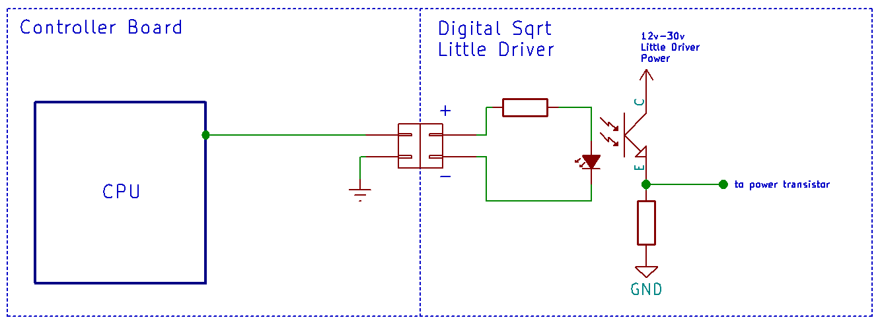

R3

I1

Q1

R2

Notes: The output power MOSFET is not shown in this diagram. The LED and Q1 are in an IC on the board. This LED is not the indicator LED.

There are some things that are worth mentioning about this circuit. The Ground (or reference) is not the same ground as on the Little Driver. In this example both devices are powered by a completely different power supply. For example: Your main control board my only be designed for 12v. But you want to use a 24V 20A heated bed. The little driver is perfect for that situation.

The LED biases transistor Q1; forcing it to conduct. All that is necessary is to make the LED light up.

Circuit example: The LED’s forward voltage is 1.4v or less. The CPU logic is 3v. We set R3 to 300 ohms Voltage across R3 = 3 - 1.4. I1 =VR3 / 300 = 5mA. For a 5v CPU I1 = 5 – 1.4 / 300 = 12mA.

Once Q1 is conducting the voltage across R2 turns on the Power MOSFET. It also acts as a charge bleed off resistor when Q1 is off.

It is also possible to us the main control board supply as the supply for the little driver. The control board and the Little driver would share a ground. This does not change the operation. Then the heated bed, Little Driver board, and Your Control board must be rated to use the same voltage.

***Using The Trigger (continued)***

Having 2 power supplies is not the only reason for optical isolation. The trigger can be used in another configuration.

Consider the configuration below.

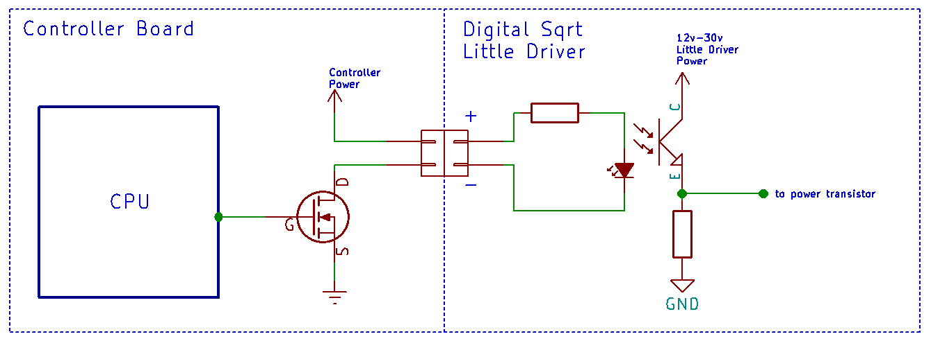

R3

I1

Q1

R2

Basically, instead of the heated bed being the load on the controller board; the Little Driver’s trigger circuit is. **Most users will be using this configuration.**

The calculations are very similar the previous configuration. Some assumptions will need to be made. We will assume that the voltage drop across the controller boards MOSFET is 0V. Also assuming that the controller’s power supply is 12v and R3 is 1.99K. Then I1 = (12v – 1.4v)/1.99K = 5.3mA. If the supply voltage was 24v then we would have I1 = (24v – 1.4v)/1.99K = 11.4mA.

Remember, 5mA is the minimum required current to get the power MOSFET to turn on. At 30mA the part has a premature death.

If you noticed we did just change the value of R3 from the previous example. When JP1is installed on the Little Driver R3 is 300 ohms. When it is removed; R3 is 1.99K.

**An important note.** If the Little Driver is being controlled by the heated bed output JP1 should NOT be installed. If it is **you will destroy the Little Driver’s opto-isolator.**

## Over Driving Your Heated Bed

Overdriving your heated bed is using a 12v bed and running it at 24v. Doing so; greatly reduces worm up times and increases top end temperature for the bed. In fact the top end temp will double.

But there in lies one of the big issues. If you’re heated bed can reach 130 deg C at 12v; now it will be doing 260 Deg C. Lead free solder melts at 188 Deg C. This sound like a fire hazard to us. WE really don’t recommend doing this.

However, we also recognize the little driver lend it’s self to this kind of activity. In that thought there are some issues that need to be addressed.

1. Your temperature-sensing device can’t save you from disaster. It provides feedback to the control board. If it breaks; the control board can turn on the heated bed to full. If your firmware supports detecting and damaged sensing unit TURN IT ON!
2. Add a fuse to the power going to the little driver. This is a good idea any way. But if things go badly hopefully the fuse will blow before something bad happens.
3. Add a thermal switch. This is an extra sensor to provide redundancy. Again if both sensors break then you are back to the original problem. How to wire it and the best implementation is up to you.

Again, we don’t recommend this. You are on your own. If your printer catches fire ……. We told you so.

## Wire Sizing

Wire is probably the most misused part of the DIY 3D printer market. Lets talk about what ratings are used when specifying the type of wire to us in an application.

Voltage – This is really specifying how good the insulation is. The high the voltage the thicker the insulation is going to be.

Current – This is the one you need to watch. Any given length of wire at a specific gauge is going to have a fixed resistance. As the current increases more and more voltage is dropped across the wire. This also causes a heating effect in the wire. I2 x R = is the energy that is being used to heat the wire. This is the same principle that your heated bed works on.

Now consider. If you have a heated bed that is rated for 12v and it draws 12A, its resistance is 1 ohms. Now lets say the wire that was used to power the bed is .25 Ohms. That is not much. But if you compare it to the heated bed; It is 25%. That is HUGE. 25% of the power intended to heat the bed is lost. These numbers are a bit of an exaggeration but the idea still holds true. Using the right size wire is very important.

Gauge – Digital Sqrt uses the American Wire Gauge. Their are lots of standards for wire diameter. For example

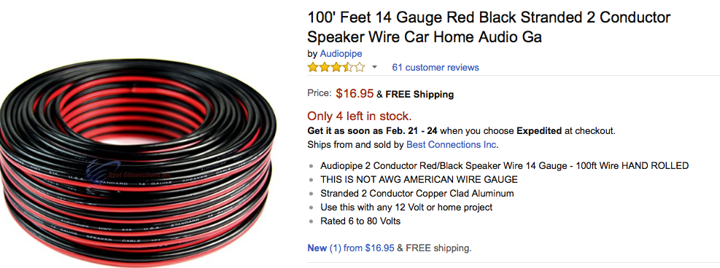

This is really between AWG18-16. (Larger numbers mean small wire size.) A 4-foot piece is only rated for 15Amps.

At the current levels that the Little Driver is capable of controlling make sure you get the right size wire.

**Wire Sizing (continued)**

What size wire should you be using? That is easy. Consult a wire gauge chart. What is not easy is; understanding why the chart specs a 7 Gauge wire for 30 Amps. That is a very large wire. Most likely you are looking a sizing chart for household wiring. **Use an automotive wire size chart.** That is closer to the application we have here.

The automotive chart suggests a wire between 14-10 AWG. That depends on the length of the wire run. With a 14 AWG wire there is 6 feet of length before the next size gauge. (That’s 3 feet of power and 3 feet of ground.) If your power supply, Little Driver and Heated Bed are all close to each other 14 AWG will work.

**We recommend 12 AWG wire.** It’s a good balance between line loss and size.

# Installation Guide

## Mounting the board

#### Mounting to 1515 or 2020 Aluminum Extrusion

If you do not have the bracket pictured (or equivalent) you can purchase one at www.Digital-Sqrt.com or print one yourself. File Name- “Al_Ext_Mounting_Bracket.stl”. The file is located at our github repository. See [www.digital-sqrt.com](https://www.digital-sqrt.com) for the link.

Step 1

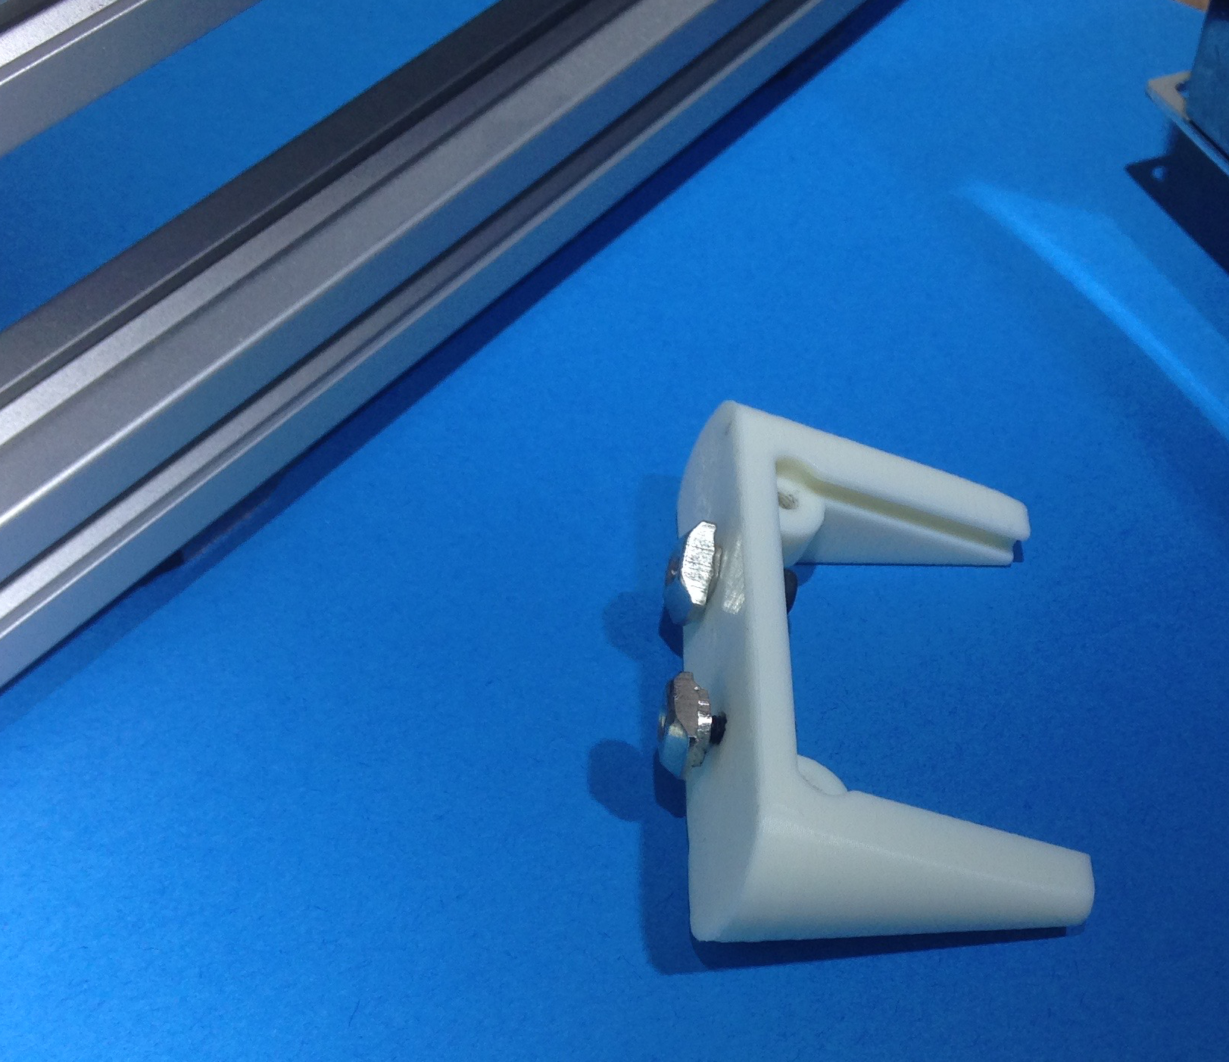

|  |  |
| --- | --- |
|  | Using 2 M3 x 8mm screws, attach the Drop-In T-Nuts to the mounting bracket. |

Step 2

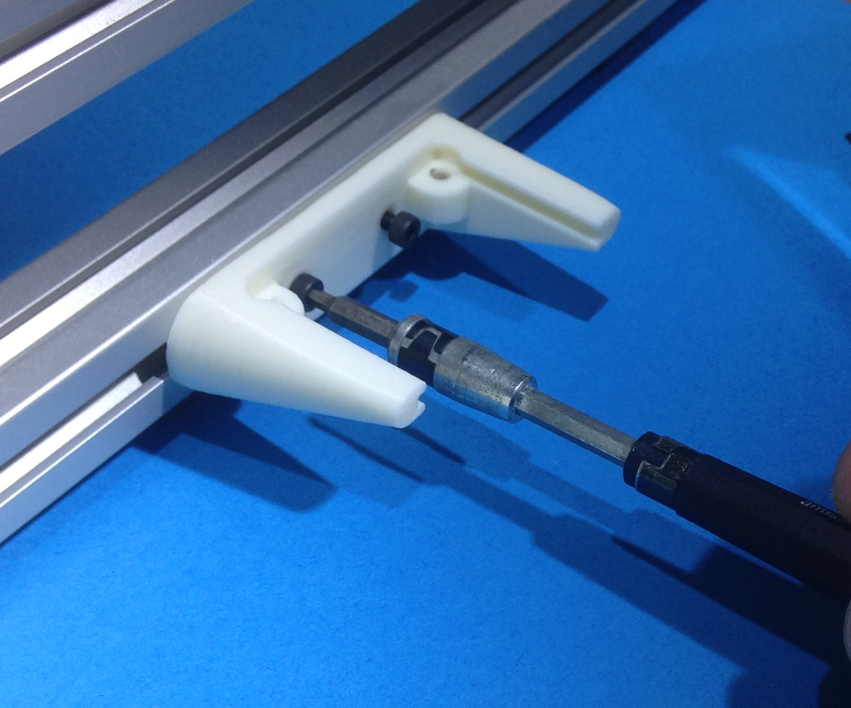

|  |  |
| --- | --- |
|  | Attach the mounting bracket to the aluminum extrusion.  A 20x20mm is pictured here. |

Step 3

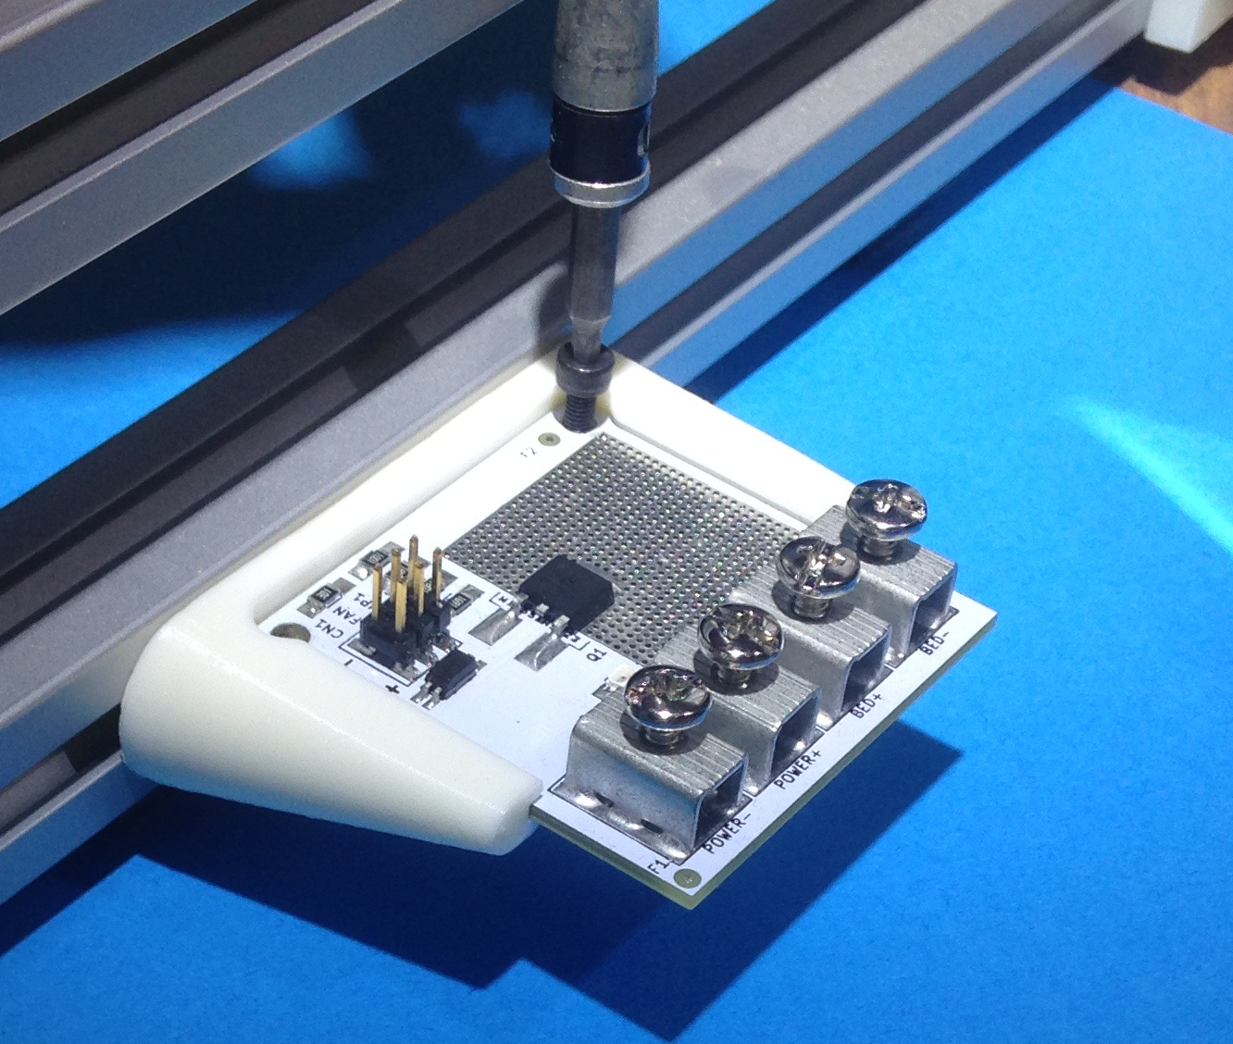

|  |  |
| --- | --- |
|  | Install the little driver as shown. Then using 2 M3x8mm screws secure the board in place. Now you can move on to the wiring section |

#### Other Mounting Options

Digital-Sqrt also has a universal mounting option. This gives the user more options when mounting the Little Driver. If you don’t have the bracket pictured below one can be obtained from [www.digital-sqrt.com](https://www.digital-sqrt.com) . You other option is to print one yourself. File Name- “Universal_Mounting_Bracket.stl”. The file is located at our github repository. See [www.digital-sqrt.com](https://www.digital-sqrt.com) for the link.

Step 1

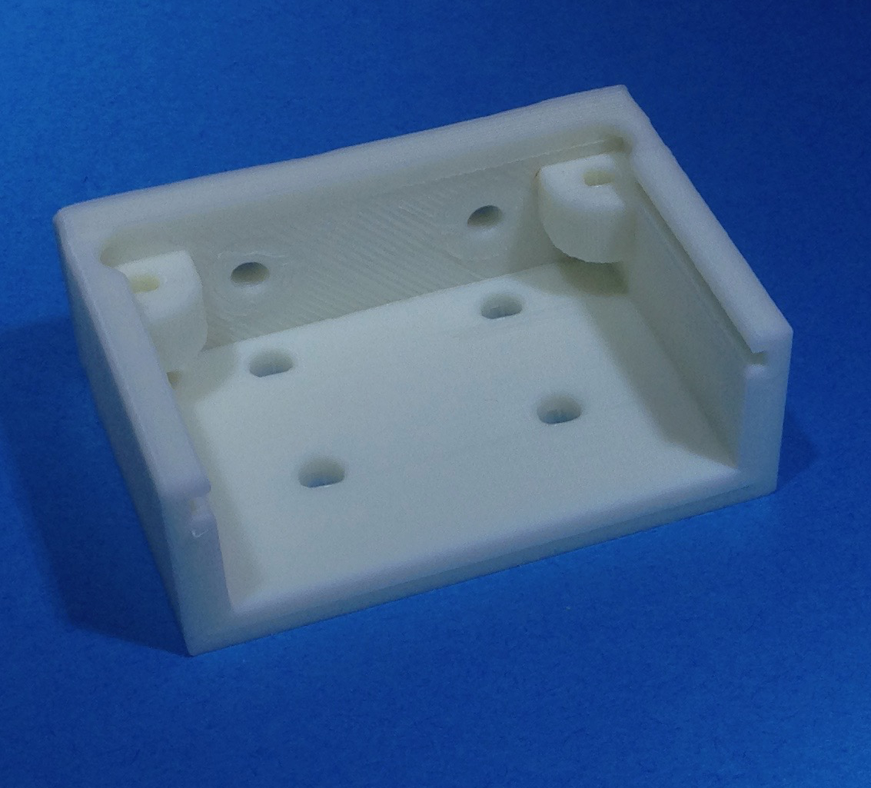

|  |  |
| --- | --- |
|  | This is the universal mounting bracket for the little driver. Their are several screw holes for various mounting options.  The holes are sized for M3 screws  Mount the bracket in the location you intend for the Little driver. |

Step 2

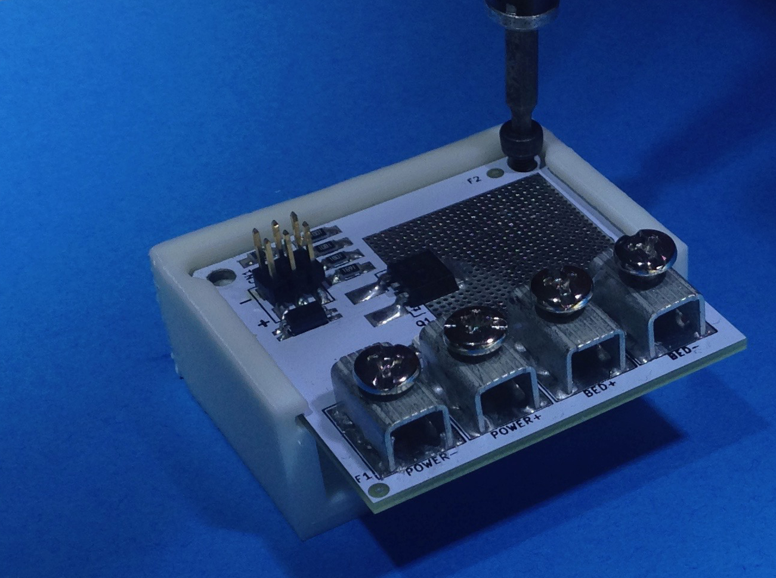

|  |  |
| --- | --- |
|  | Install the little driver as shown. Then using 2 M3x8mm screws secure the board in place.  Now you can move on to the wiring section |

## Wiring

These instructions are for board ver 1.5. Ver 1.7 has a different lay out. Ground and power are in different locations. The instructions are the same but the pictures will not match.

If you don’t have your wires prepped for installation do that now.

If you don’t have a wiring kit one can be purchased from [www.digital-sqrt.com](https://www.digital-sqrt.com). The bill of materials can be downloaded from our github repository. File Name- “Little_driver_wiring_kit-BOM.csv”. See [www.digital-sqrt.com](https://www.digital-sqrt.com) for the link.

Step 1

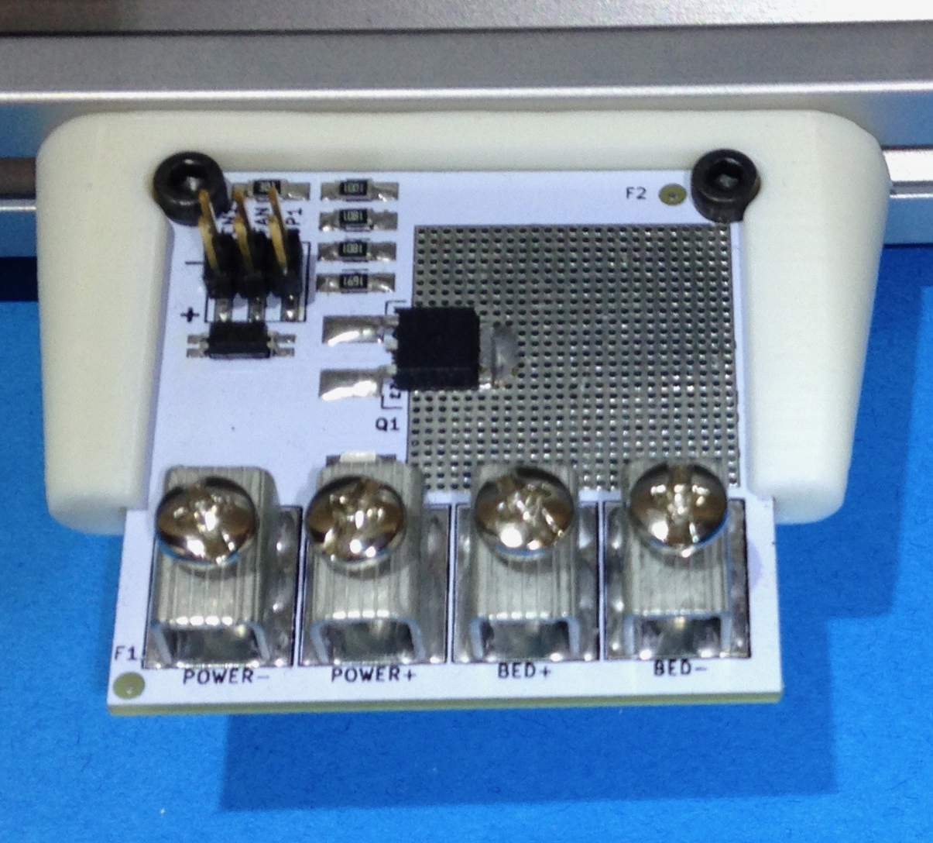

|  |  |
| --- | --- |
|  | Remove the power plug from you power supply. Also insure that the supply has fully discharged.  Be VERY sure JP1 is NOT installed. |

Step 2

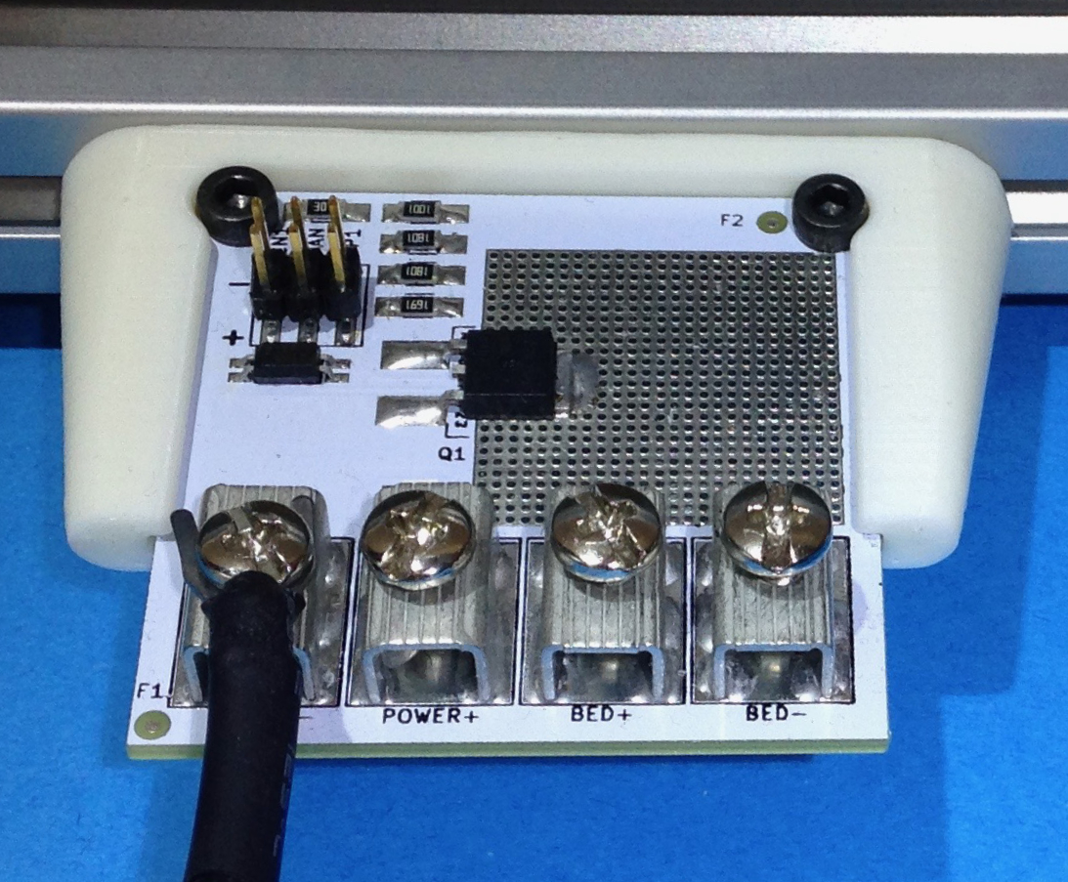

|  |  |
| --- | --- |
|  | Install the ground-side of the power supply where the board is marked “ POWER -“.  Power supply wires are marked with black heat shrink. |

**Wiring (continued)**

Step 3

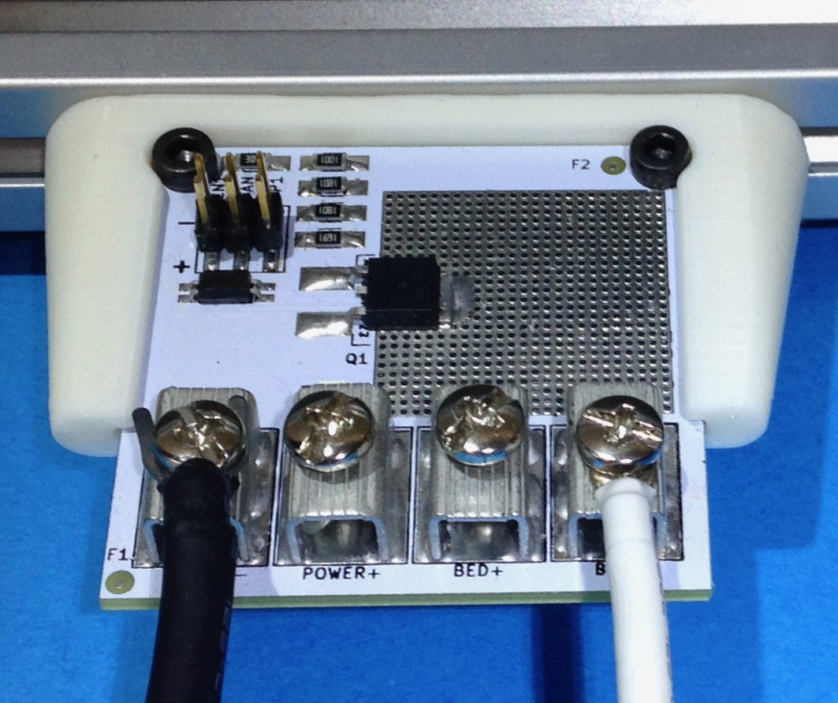

|  |  |
| --- | --- |
|  | Install the Negative side of the heated bed where the board is marked  “BED -“.  Heated bed wires are marked with white heat shrink. |

Step 4

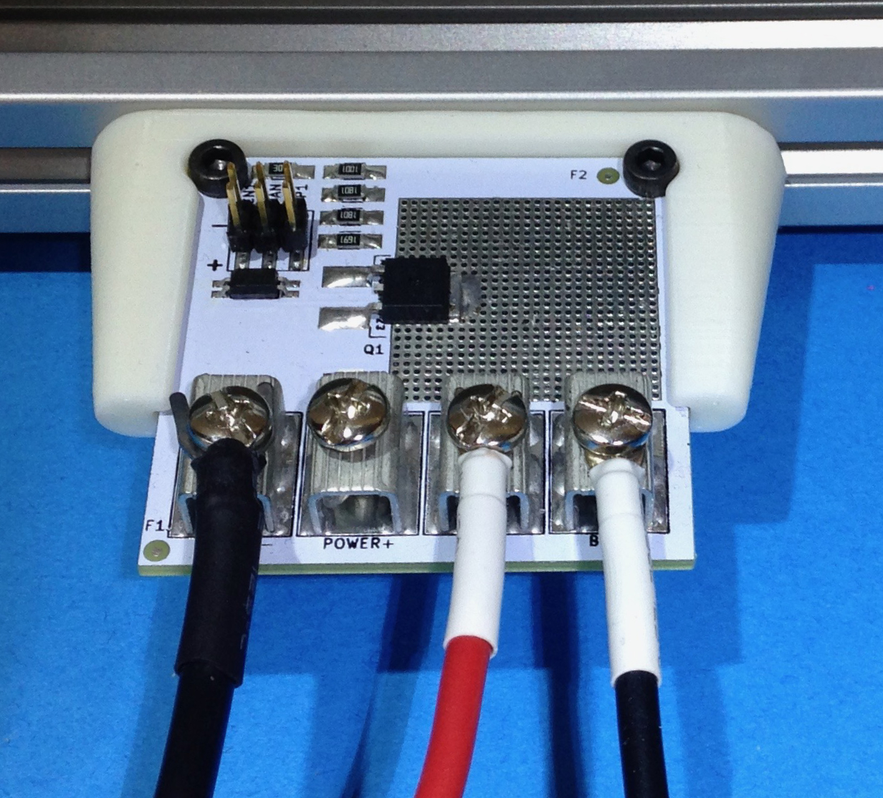

|  |  |
| --- | --- |
|  | Install the Posative side of the heated bed where the board is marked  “BED +“.  Heated bed wires are marked with white heat shrink. |

Step 5



|  |  |
| --- | --- |
|  | Install the Positive side of the power supply where the board is marked “ POWER +“.  Power supply wires are marked with black heat shrink. |

Step 6

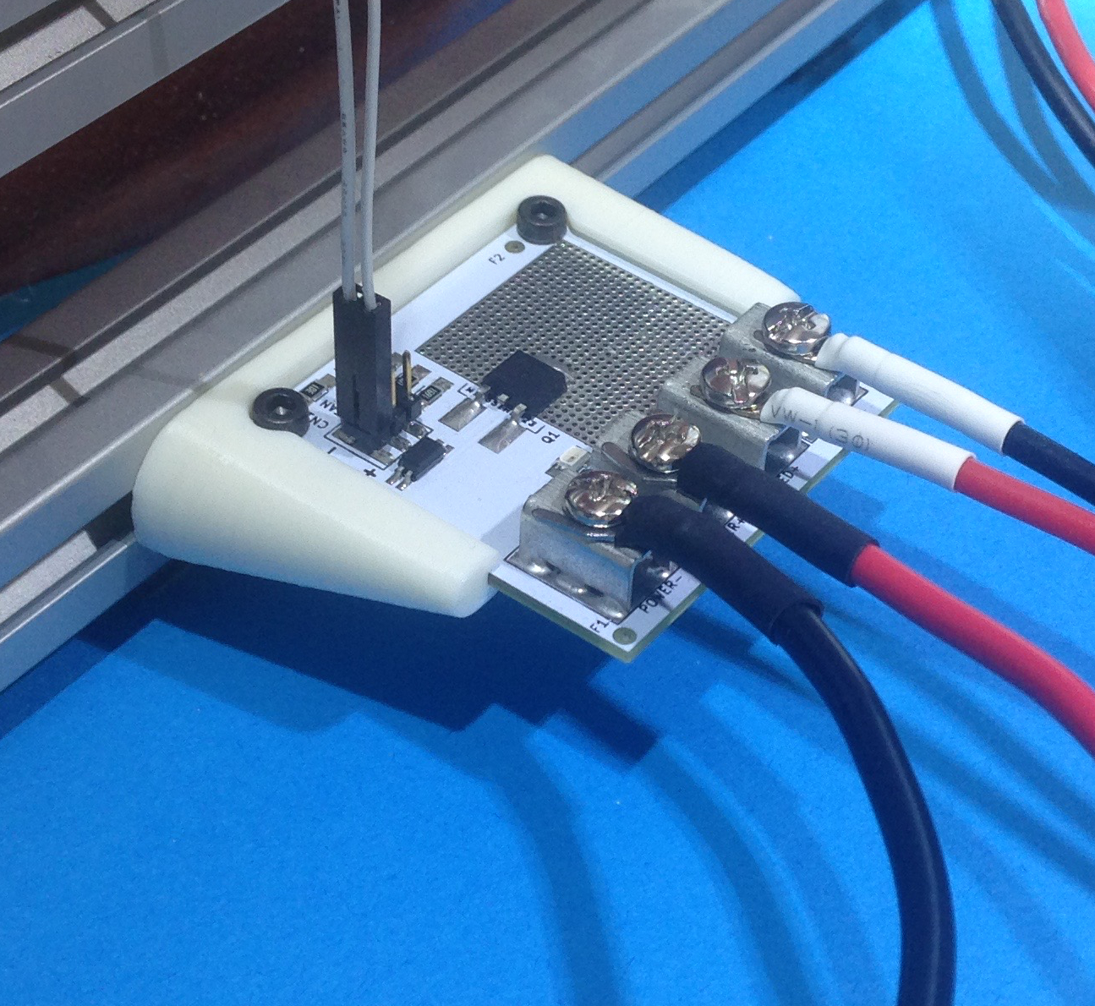

|  |  |
| --- | --- |
|  | Install CN1 cable.  If your cable has the same color wire for both pin use tape to mark the positive wire. |

## Controlling from an Existing Heated Bed Output

If you are NOT using the existing heated bed output as the control skip this section.

This method of control uses the heated bed drive transistor that is on your control board. **If JP1 is installed** you will **destroy the opto-isolator** on the board.

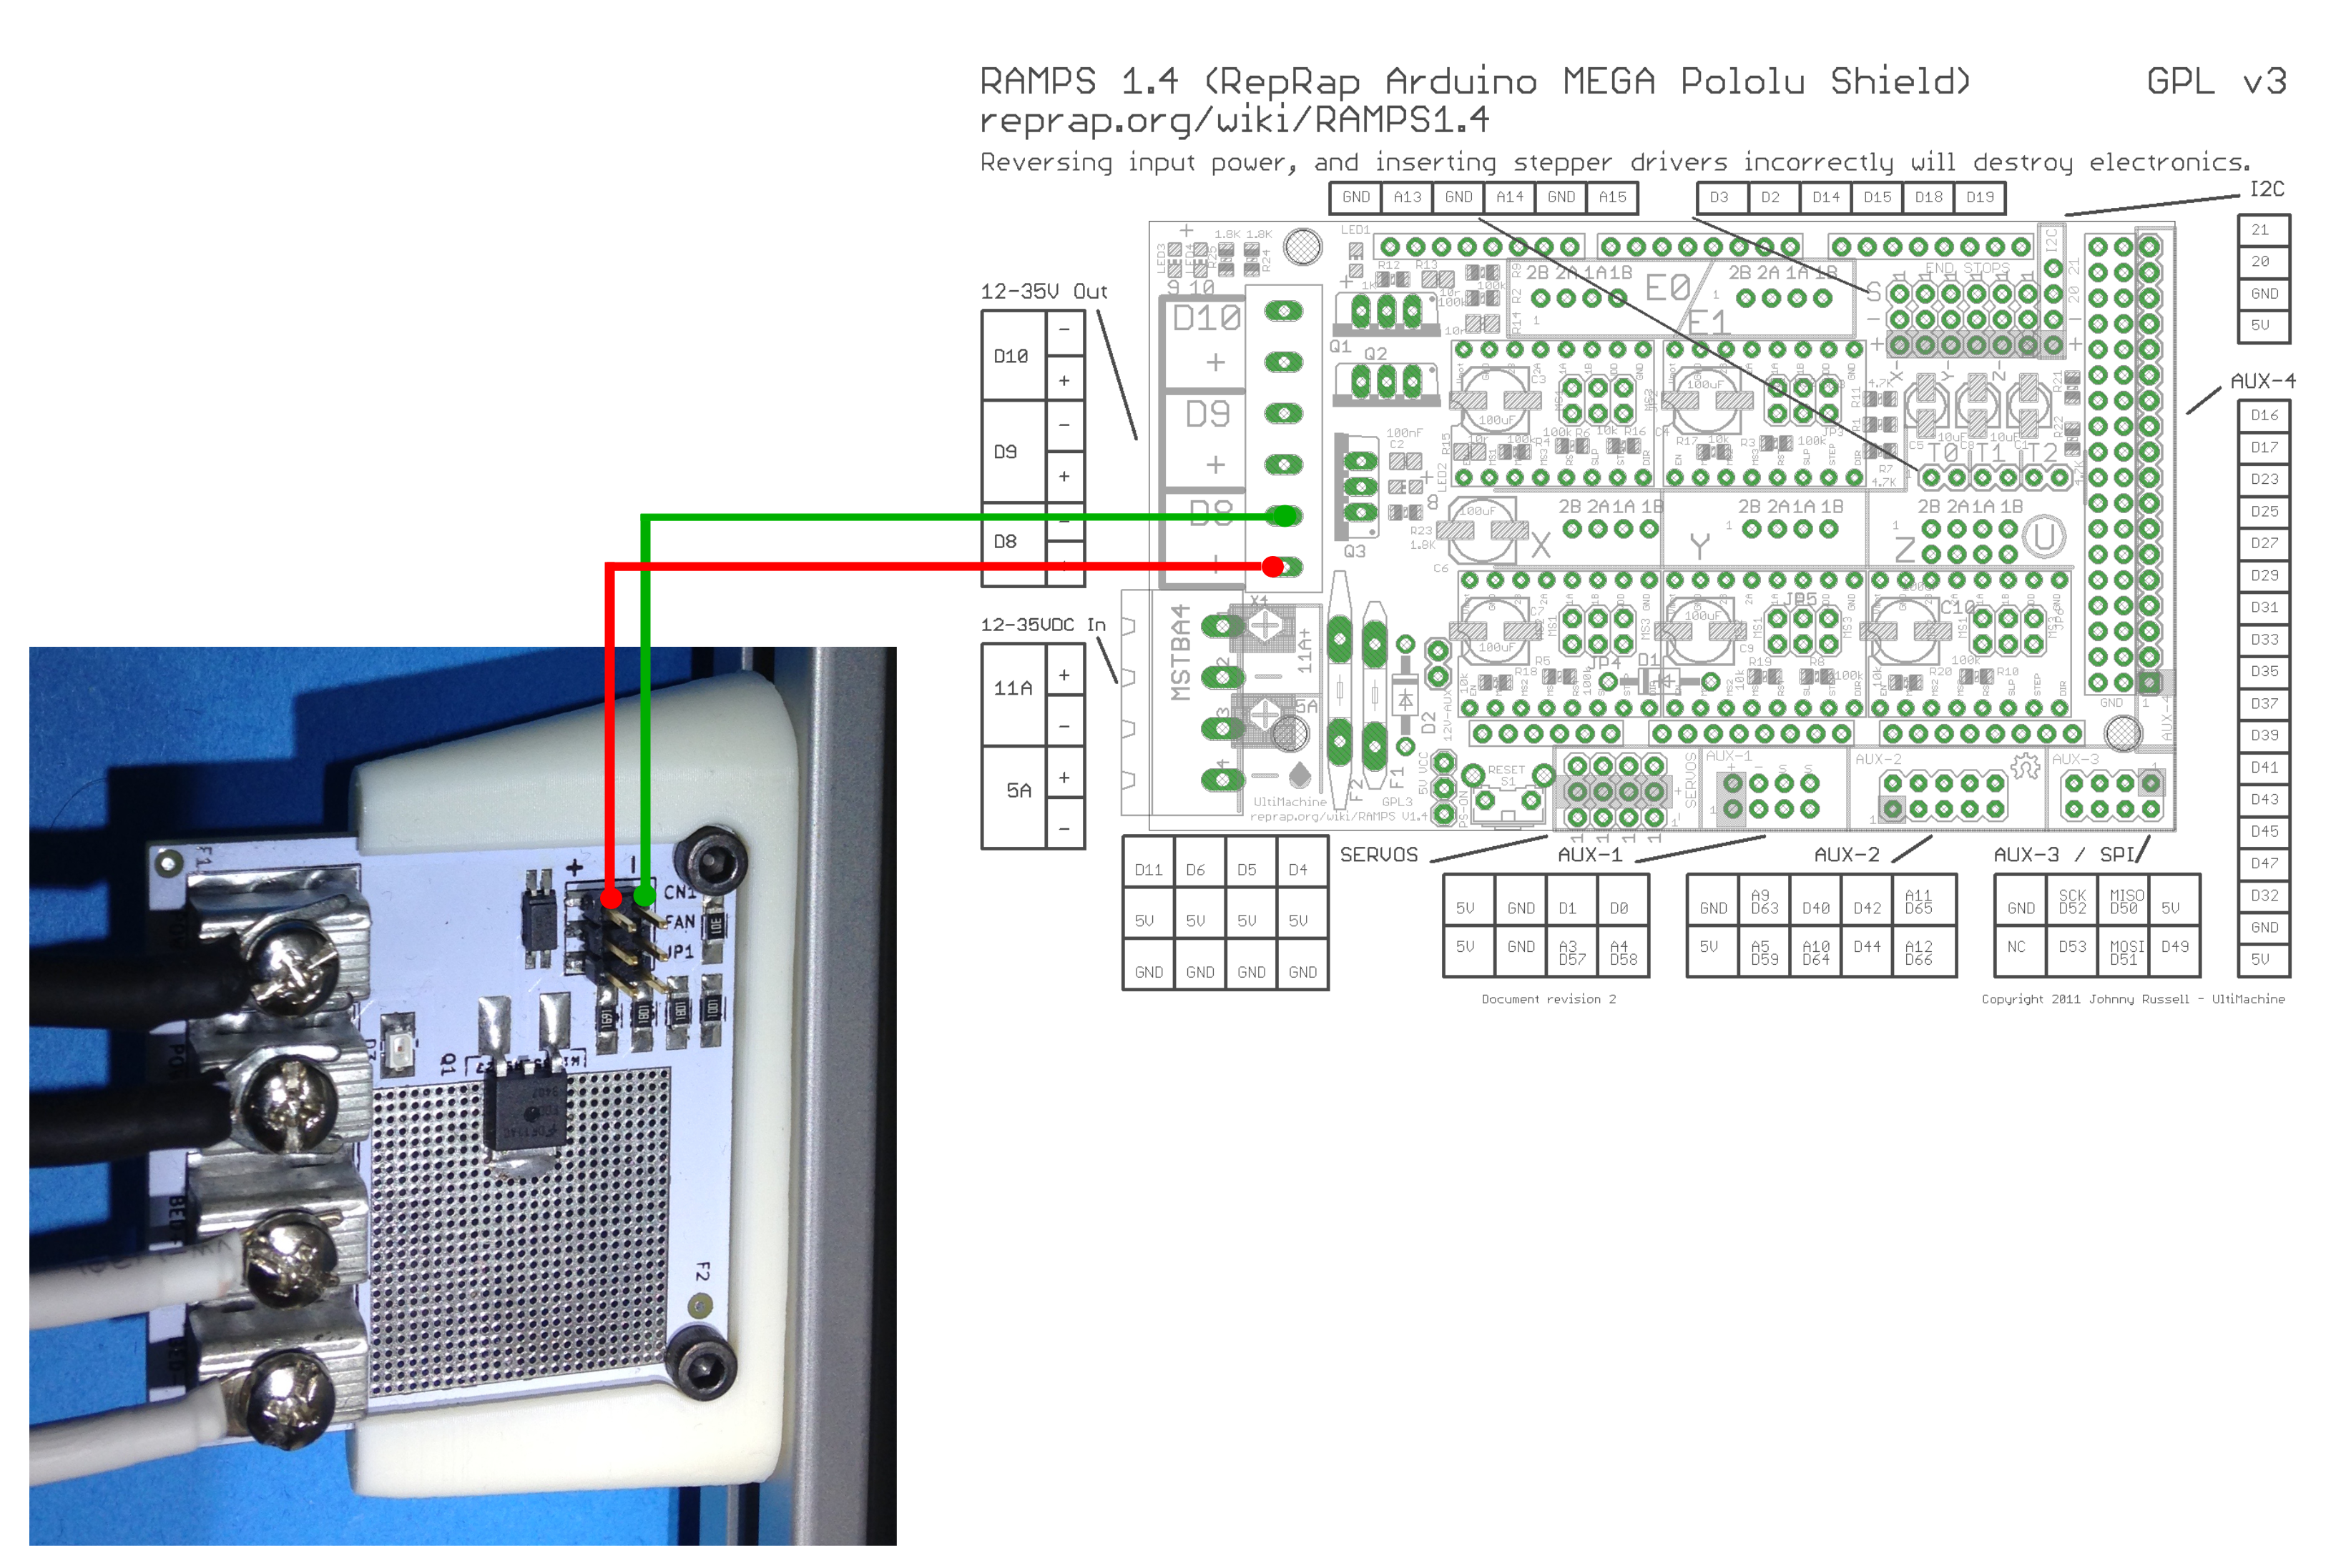

Connect control lines to RAMPS

CN1+ to D8+

CN1- to D8-

To connect the Little Driver to a RAMPS board connect CN1+ to D8+ and CN1- to D8-.

There are many different control boards on the market. The connections to you board may be slightly different. See the “Theory of Operation” section and review your controller boards documentation.

## Controlling from an CPU digital output

This option is a bit tricky. There are so many boards on the market that getting this right is going to be hard.

1. Connect the Little Drivers CN1- to the controller boards ground. Let me repeat that connect **CN1- to the CONTROLLER BOARDS GROUND**.
2. Connect CN1+ to the Digital output from the controller boards micro.
3. Now install JP1. This is the only case where JP1 can be installed. In fact the out from the board **cannot exceed 7v** or the **opto-isolator will be destroyed.**

## Setting up the Little Driver to replace a damaged transistor.

You will need to be an advanced user of your control board in order to make this work.

These instructions assume 2 things

1. That your control board is using some sort of MOSFET to control the heated bed.
2. The MOSFET is a 3 Terminal device. (The tab does not count but may be electrically connected)
3. That the MOSFET is configured as a low side driver.

(MOSFET Source is tied to GND, The gate is tied to the CPU pin, and the Drain is where the Heated Bed negative terminal was tied) This is the way RAMPS 1.4.0 is configured.

**DISCONNECT THE HEATED BED FROM THE CONTROLLER (both wires)**

There are **2 points** you will need to **find**. The **Gate** of the transistor and the **Source**.

The **Source** is easy to find. Use a mulit-meater in continuity mode and find the MOSFET terminal that is connected to ground. This **is where CN1-** will be **connected**.

Using your mulit-meater in continuity mode find the MOSFET terminal that is connected to the HEATED -. That terminal will be the Drain. The drain is not needed. However; the pin that has not been identified is the Gate.

**The Little Drivers CN1+ will be tied to the Gate.**

**Now JP1 can be installed.**

An easier way to do all this is to read the part number off of the device and look up the data sheet. Many the controller boards come from China. I have found that identifying Chinese parts can be difficult.

# Little Driver Electrical Specifications

|  |  |  |  |
| --- | --- | --- | --- |
|  | | Min | Max |
| CN1 INPUT | If | 4mA | 20mA |
| Vin (JP1 installed) |  | 7.0v |
| Vin (JP1 NOT installed) |  | 30.0v |
| Reverse Voltage |  | 6.0v |
| Power Supply | Voltage | 10v | 30v |
| Current |  | 30Amp |
| Output  (@25 deg c) | Voltage | 10v | 30v |
| Current |  | 30Amp |